FARM SMART to welcome 100,000th visitor, new manager

by Sam Urie
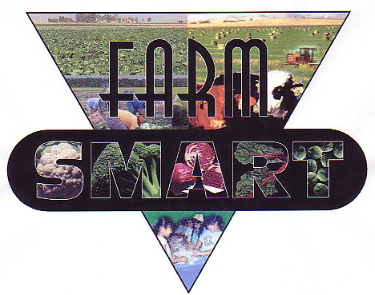
Figure 1. FARM SMART logo.
FARM SMART is an educational outreach program based at UC ANR’s Desert Research and Extension Center (DREC) in Holtville, CA. The program focuses on agricultural and natural resources literacy and community outreach. The program was created in 2001, and is the brainchild of Nancy Caywood-Robertson. FARM SMART grew from Caywood-Robertson’s master’s thesis in agricultural education to the program it is today through generous donations, volunteer work, and Nancy’s boundless energy and passion for teaching agriculture. The program now invites thousands of K-12 students to the research farm each year for tours of the farm and hands-on education. With program titles such as “My Agrilicious Food Pyramid” and “Alfalfa is Ice Cream in the Making”, FARM SMART offers the community an unparalleled educational resource. Students pick vegetables from the four acre FARM SMART garden, learn about research being done on the farm, and realize where their food comes from in a fun and educational way. Nancy and her husband, Al Robertson, have used their musical talents to augment the program and have even created a CD of songs they perform for the program.
FARM SMART also hosts thousands of “snowbirds” from Canada and the northern U.S. during January and February each year through its “Winter Visitor” program. Attendees are treated to a field tour, pick produce, and learn about and experience area agriculture. Visitors have lunch on the patio and can ask questions about area farming practices at the “Get Farm Smarter” booth. FARM SMART will recognize its 100,000 visitor this year during the Winter Visitor program.
FARM SMART and DREC would like to recognize Nancy Caywood-Robertson’s many years of service and wish her the best as she retires after the winter visitor season. Sam Urie has been hired as the FARM SMART manager and will strive to continue the program’s success along with existing FARM SMART program representative Stephanie Collins. Sam Urie has a bachelor’s degree in agricultural education from Utah State University. He has professional experience with the USDA-ARS Forage and Range Research Lab in Logan, Utah, as well as over three years of experience teaching agriculture in a high school setting. Sam grew up in Utah and has been around farming for as long as he can remember and was heavily involved in FFA in high school.
Learn more about FARM SMART and DREC at ucanr.edu/sites/desertresearch or call the FARM SMART office at 760-356-3067.

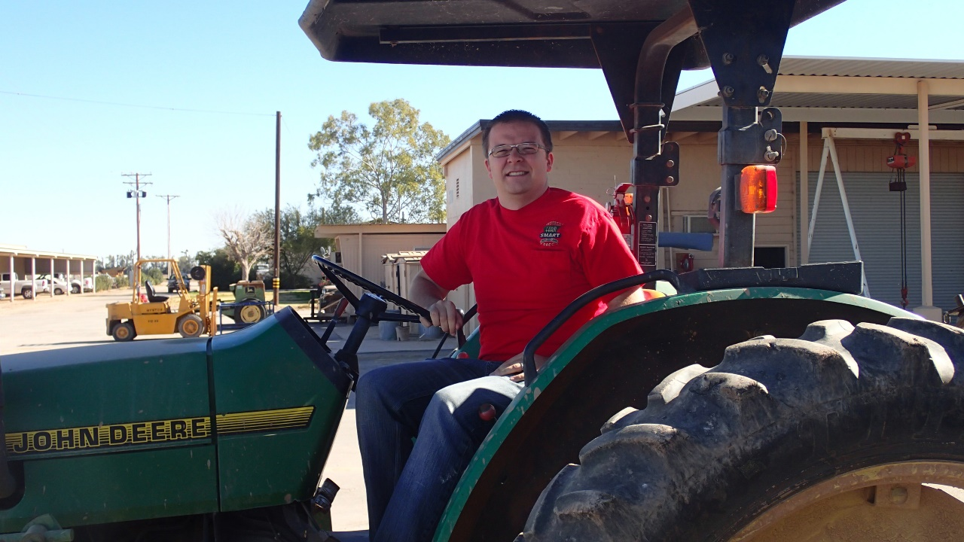
Figure 2. New Farm Smart manager Sam Urie.

